SOP Of Ajit Bakery

**For Operations:**

Step 1. **Login Page**.

1. Enter Username.
2. Enter Password.

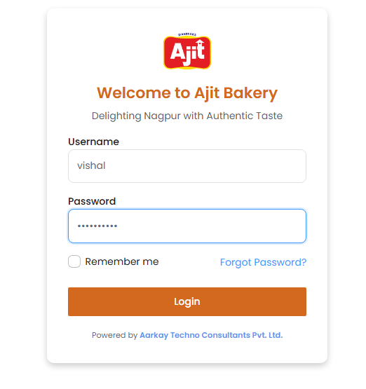

Step 2. Click on **Operations** and **Production Planning**.

1. Click on Upload Excel.

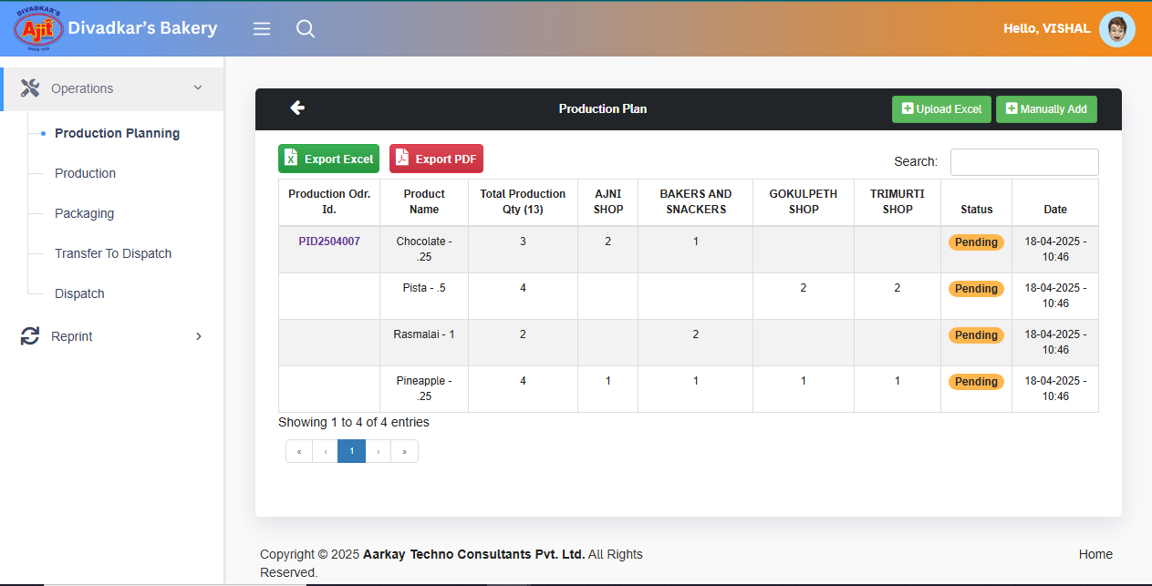

1. Click on Download Excel Template for Production Capture and in that excel file According to the Product enter Quantity against Outlets.
2. Click on Choose File and Save

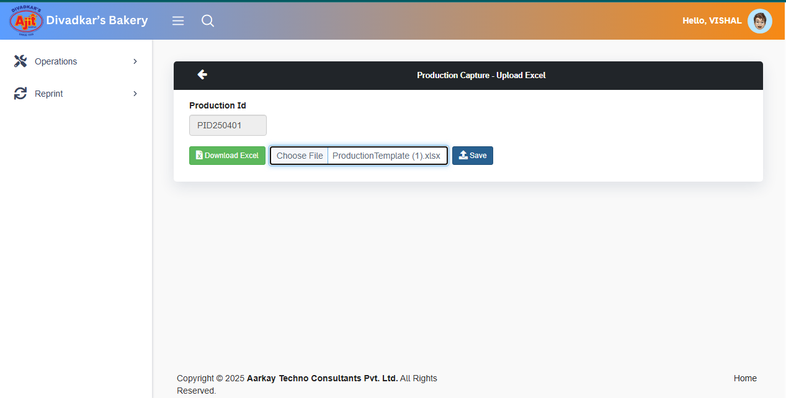

Step 3. If you Forget to Mentioned other Product quantity against Outlet then you have to Click on **Manually Add** option.

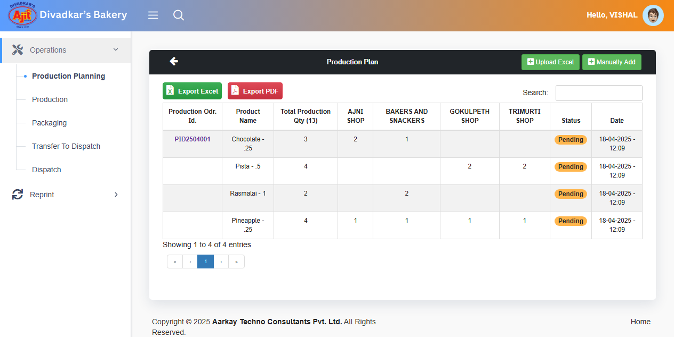

1. Select Production Id from the dropdown.
2. Select Outlet Name from the dropdown.
3. Select product Name from the dropdown.
4. Select Design from the dropdown.
5. Enter Total Quantity.
6. Click on Save

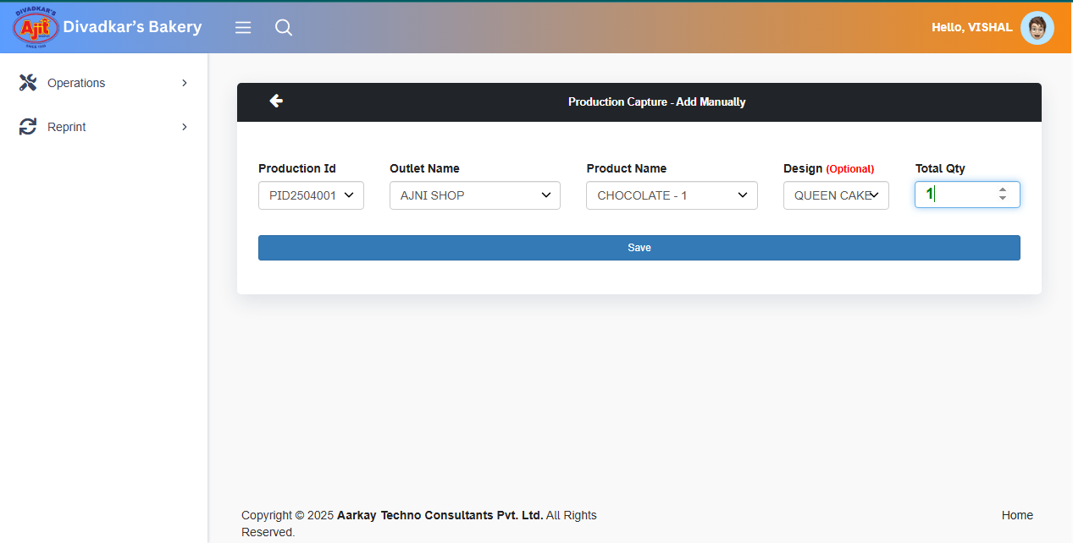

**Step 4**. Click on **Production**.

1. Click on **Save Production**.

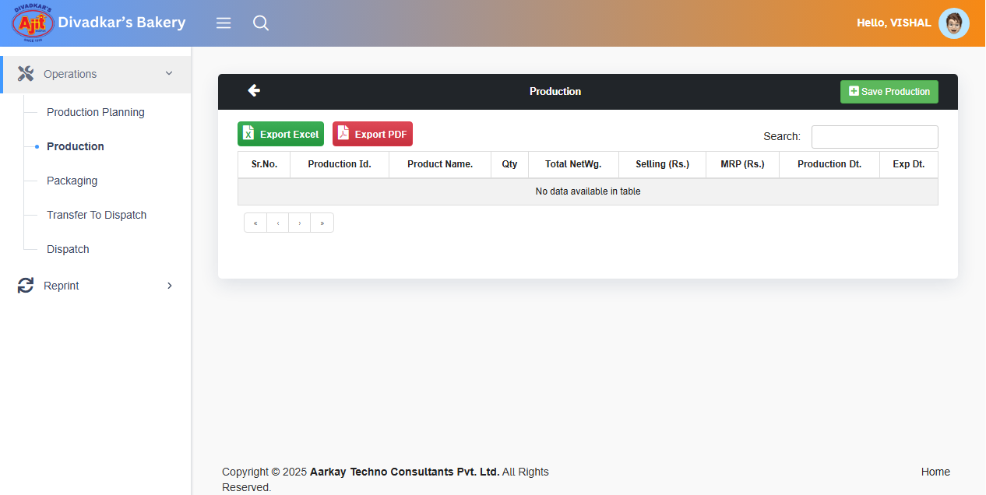

1. Select Product Id.
2. Select Production Product from the dropdown.
3. Select Dial Code from the dropdown.
4. Click on **Get Wt.**
5. Enter Product Gross Wt.
6. Click on **Save**

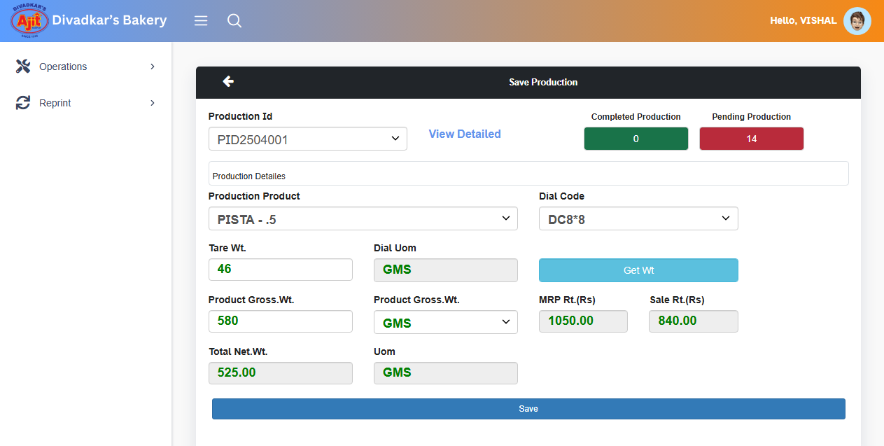

**Step 5.** Click on **Packaging**.

1. Click on **Packaging**.

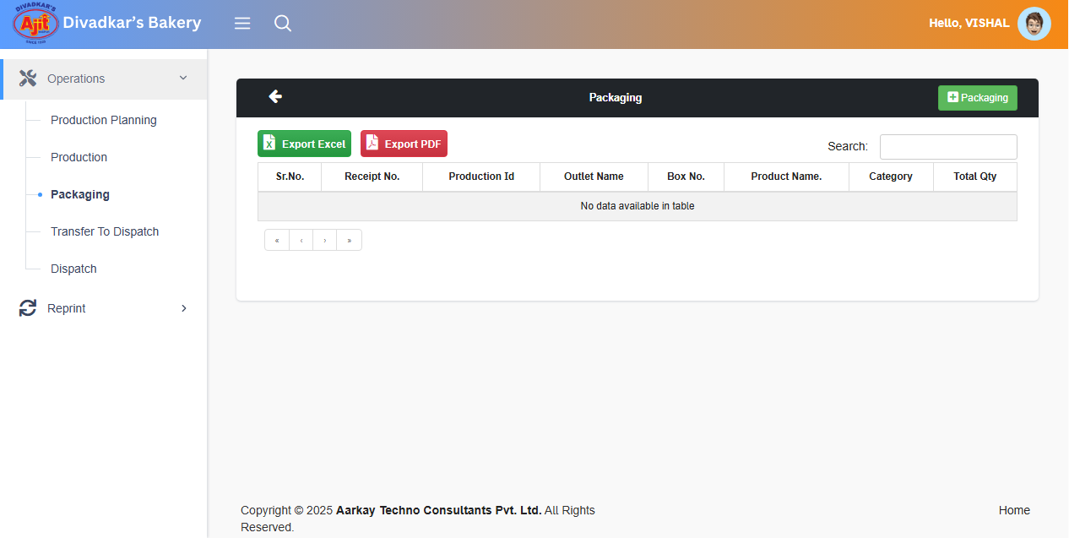

1. Select Production Id.
2. Select Outlet Name from the dropdown.
3. Select Box No. from the dropdown.
4. Scan Item Stickers.

Click on **Generate Receipt**.

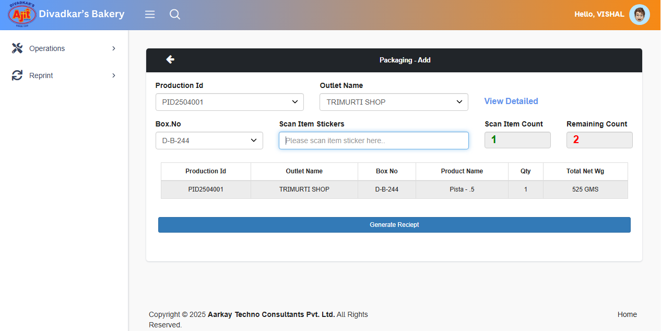

**Step 6.** Click on **Transfer To Dispatch**.

1. Click on **Transfer to Dispatch**.

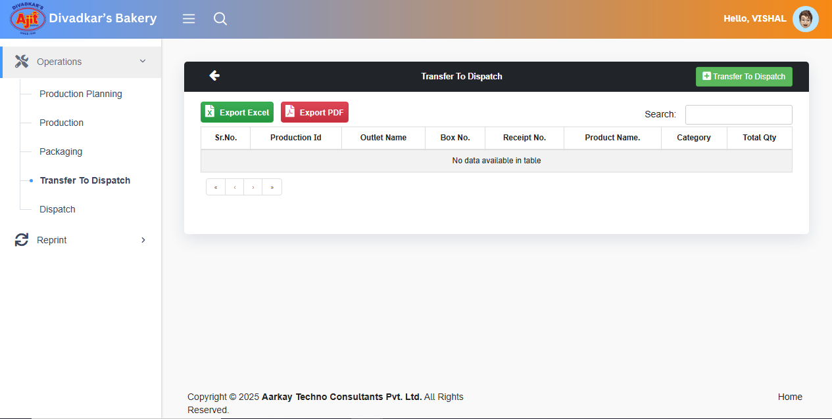

1. Scan Box or Receipt Barcode.

**Click on** **Ready To Dispatch**.

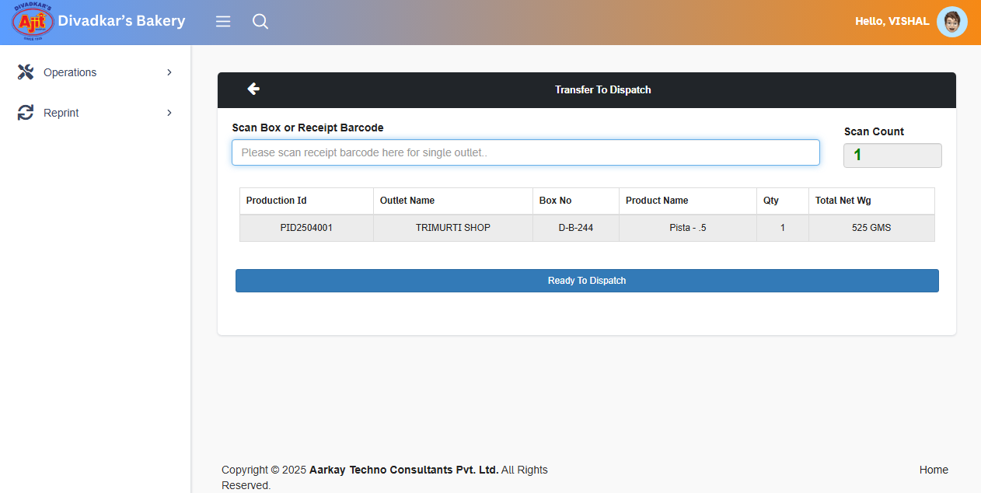

**Step 7.** Click on **Dispatch.**

1. Click on **Dispatch Process**.

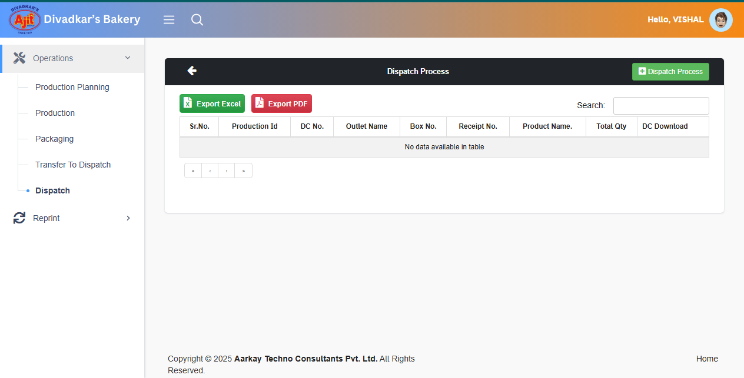

1. Select Voucher Type.
2. Select ProductionId
3. Select Outlet Name.
4. Scan Receipt Barcode.
5. Select Vehicle Own from the dropdown.
6. Select the Driver Name from the dropdown.

Click on **Submit**.

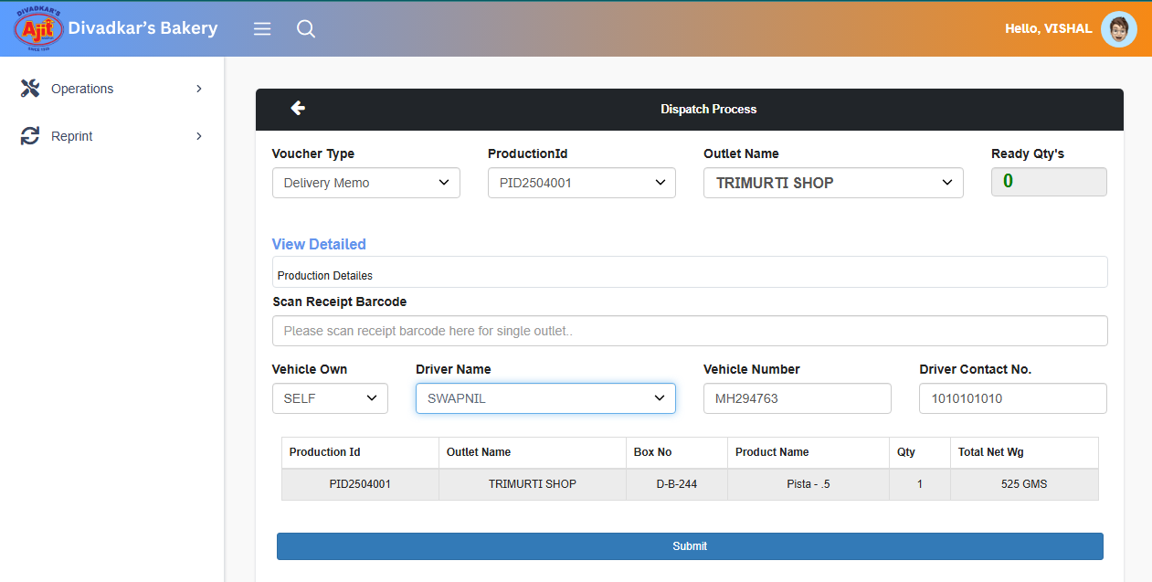

**If You loss the Item Sticker or Packaging Receipt. You have to follow Below Process.**

Click on **Reprint.**

1. Click on **Item Sticker**
2. Select the Box which Reprint Stickers.
3. Click on **Reprint Selected**.

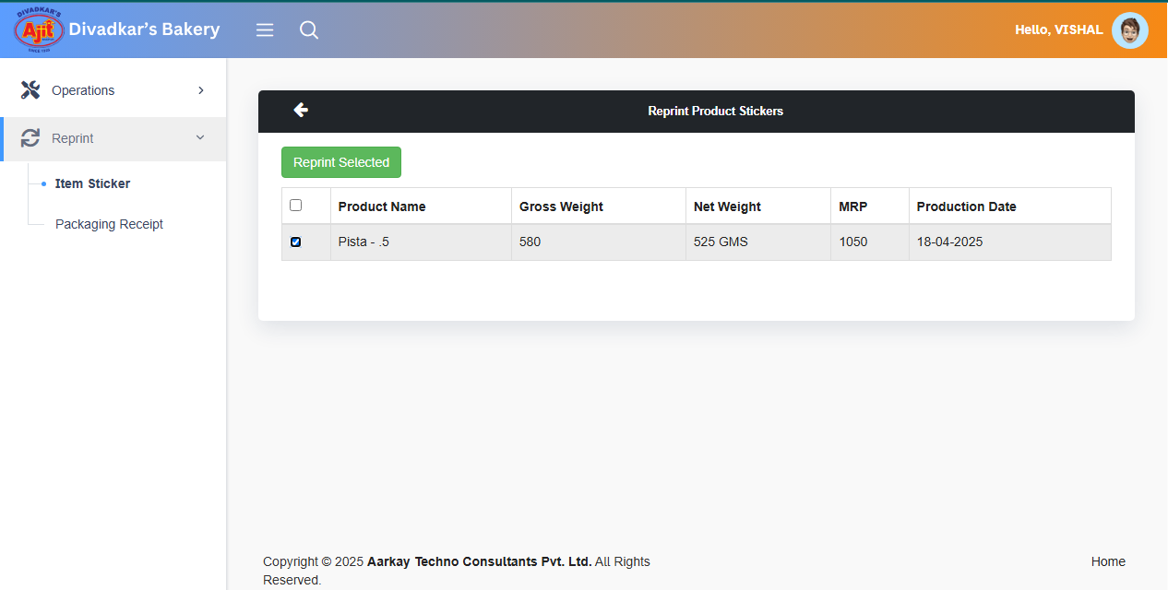

1. Click on **Packaging Receipt**.
2. Select the Box which Reprint Product Stickers.
3. Click on **Reprint Selected**.

